How to Reset Your MHA Passwords
This guide is to help you reset the passwords for your MHA account and Jibble. Your MHA account allows you to access various systems such as logging into MHA computers, MHA emails, and mymha. Jibble is the time and attendance system used to clock in and out of your shifts. This uses a separate password to your MHA account and therefore has a different password reset process.

To reset your MHA account password, you will need to know your username and password. For most colleagues your username is your payroll number, however long-serving colleagues will use their first initial and surname instead e.g. JSmith.

If you do not know your password, and you have not previously enrolled, or if you have forgotten the answers to your security questions, you will need to contact the IT Service Desk to request a temporary password. You must reset the temporary password before you can access any MHA systems. You can contact the IT Service Desk through the following methods:

- Email: ITServiceDesk@mha.org.uk
- Telephone: 01332 221888 (Option 2)
- 4me Self-Service: https://mha.4me.com/self-service

After resetting your password, you should complete enrolment. Enrolment will allow you to reset your own password without needing to contact the IT Service Desk for help.

Contents
How to Reset Your Password and Enrol Using a Non-MHA Computer 2
How to Reset Your Password Using an MHA Computer 4
How to Reset Your Password Using a Mobile Phone or Tablet 6
How to Reset Your Jibble Password 7

How to Reset Your Password and Enrol Using a Non-MHA Computer

- Go to https://passwordreset.mha.org.uk/

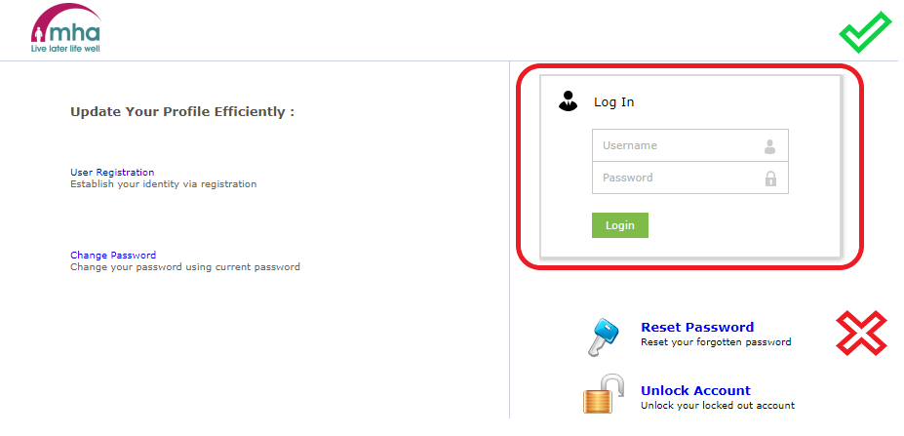
- Enter the username and temporary password in the ‘Log In’ box highlighted below *(do not use the ‘Reset Password’ link)* and click ‘Login’:

- Enter the temporary password in the ‘Old Password’ field.

- Enter a new password of your choice in the ‘New Password’ and ‘Confirm New Password’ fields.
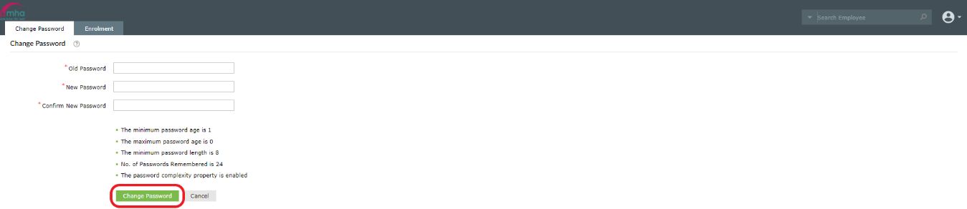
  - The password must be a minimum of 8 characters long and contain at least one capital letter, lowercase letter, number and special character e.g. !, ?, @, etc.

- After entering your password, click ‘Change Password’.

- An on-screen notification will notify you if your password has been changed successfully or not. If unsuccessful you will need to try again. If you have changed password successfully you can now progress to enrolment.

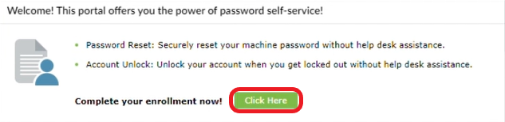
- After resetting your password, you will be prompted to enrol. Select the ‘Click Here’ button to begin enrolment.

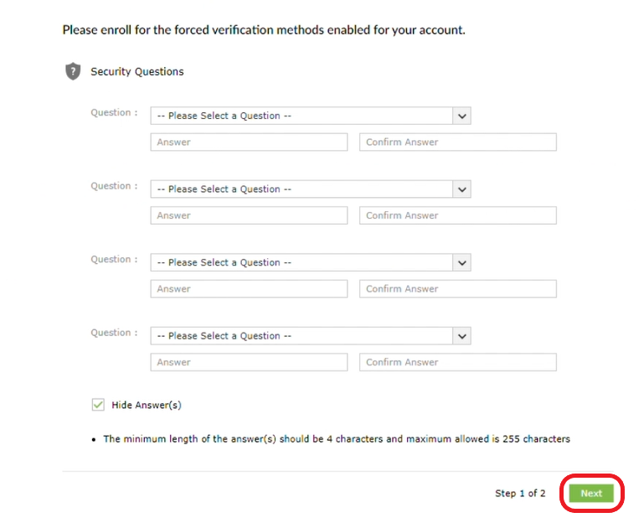
- You must now set four security questions. The questions can be selected from the dropdown menus. Ensure to confirm your answers before clicking the ‘Next’ button.

- You must now enter and verify a personal email address. This will allow you to receive a code to your email which will enable you to reset your own password in the future.

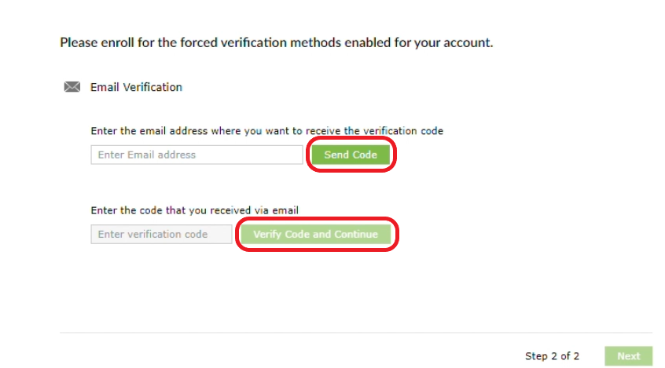
- Enter your personal email address and click ‘Send Code’. You will receive a verification code from ‘passwordresetmail@mha.org.uk’, check your Spam folder if it does not appear in your inbox.
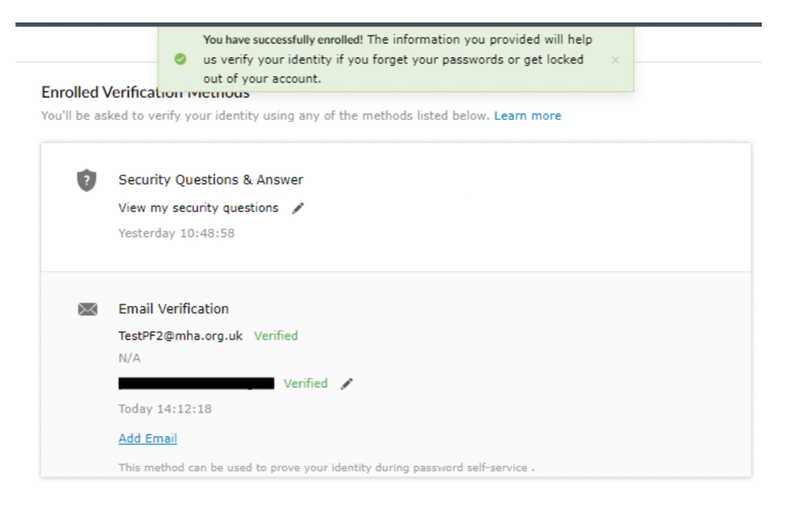
- Enter the code that you receive, then click ‘Verify Code and Continue’ to complete enrolment. You can add further verification emails if you wish.

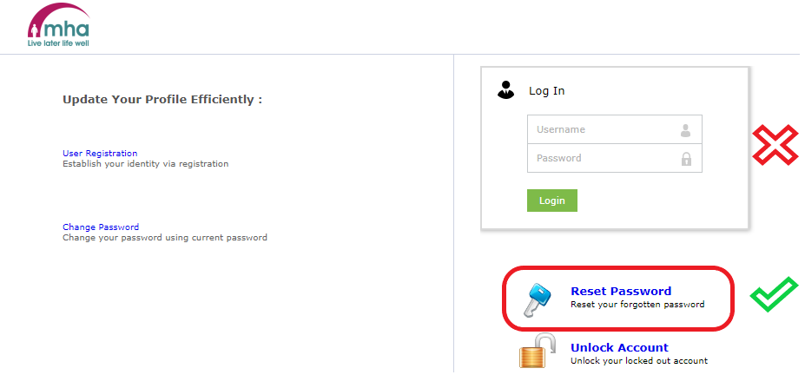
- In the future, you will now be able to use the ‘Reset Password’ button to reset your own password.

How to Reset Your Password Using an MHA Computer
- Open an MHA Laptop or Desktop and enter your username and temporary password in the ‘Username’ and ‘Password’ fields.

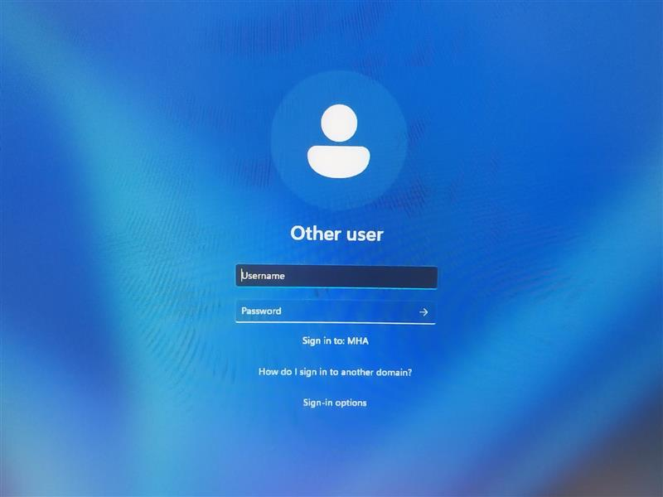
- Click the arrow to sign-in.

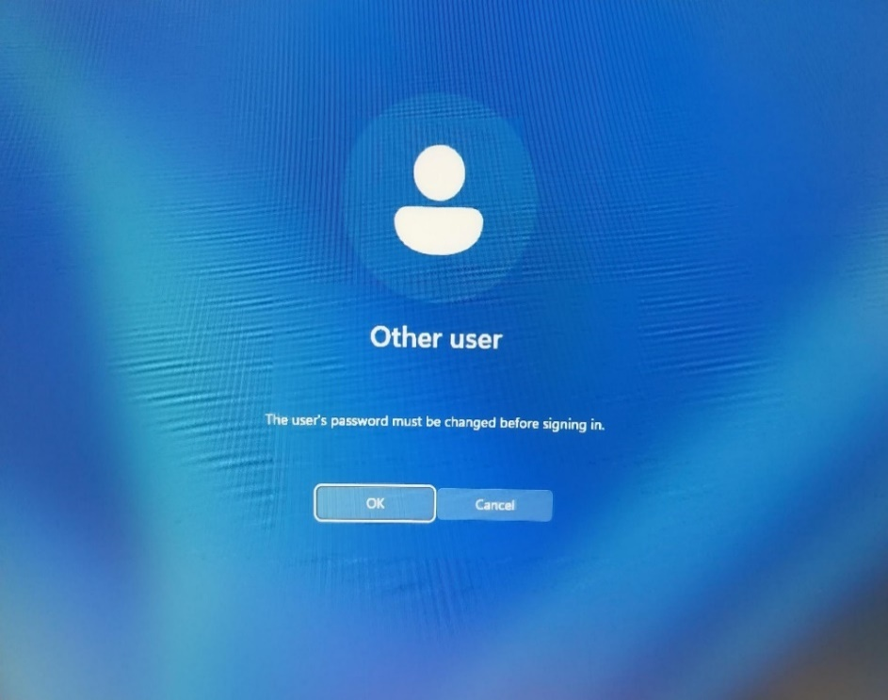
- You will then be prompted to change your password before you sign in to your account, please press ‘OK’.

- Enter your temporary password in the ‘Current password’ field.

- Enter a new password of your choice in the ‘New password’ and ‘Confirm password’ fields.

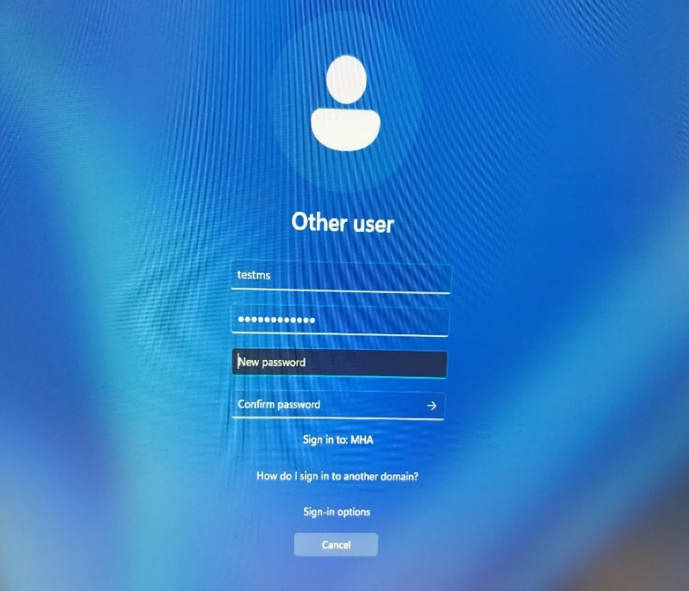
  - The password must be a minimum of 8 characters long and contain at least one capital letter, lowercase letter, number and special character e.g. !, ?, @, etc.

- Click the arrow to confirm the change of password and sign in.

How to Reset Your Password Using a Mobile Phone or Tablet
- Go to https://passwordreset.mha.org.uk/ or open the ADSelfService Plus app on a work mobile.

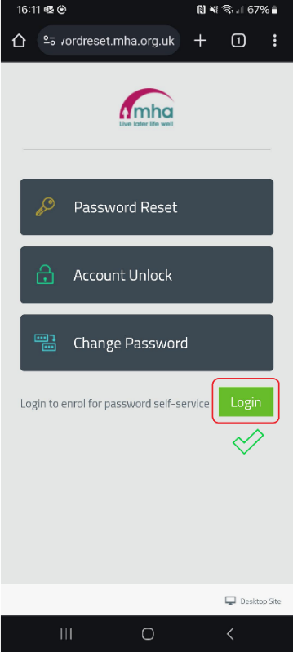
- Tap on the ‘Login’ link and *not* the ‘Password Reset’ link:

- Enter the username and temporary password then tap ‘Log In’.
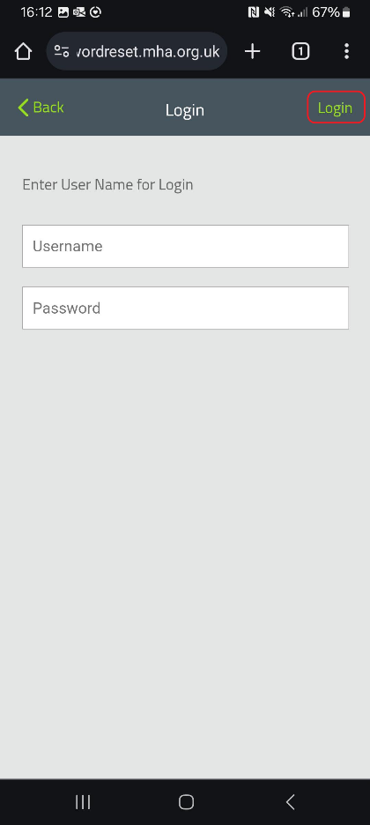
  - If you only see a blank white screen, you will need to attempt the password reset process on a computer instead.

- Tap ‘OK’ when you are prompted to reset your password with the message ‘You must change password to proceed login’.

- Enter the temporary password in the ‘Old Password’ field.

- Enter a new password of your choice in the ‘New Password’ and ‘Confirm Password’ fields.
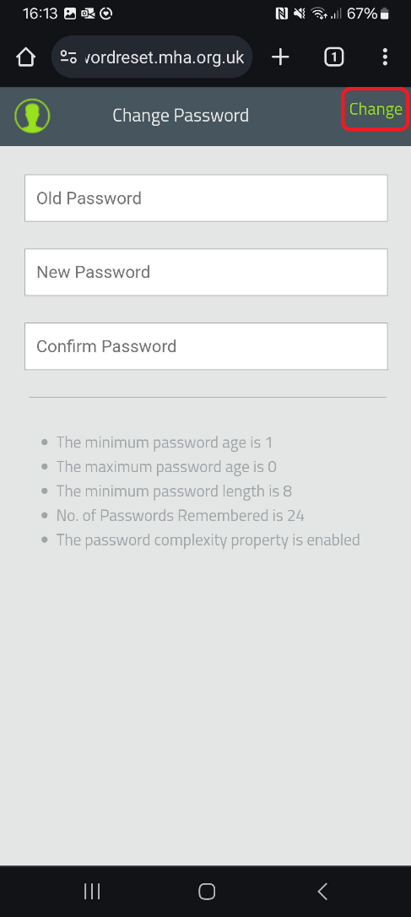
  - The password must be a minimum of 8 characters long and contain at least one capital letter, lowercase letter, number and special character e.g. !, ?, @, etc

- After entering your new password, tap ‘Change’.

How to Reset Your Jibble Password
- Open the Jibble app on your mobile or tablet.

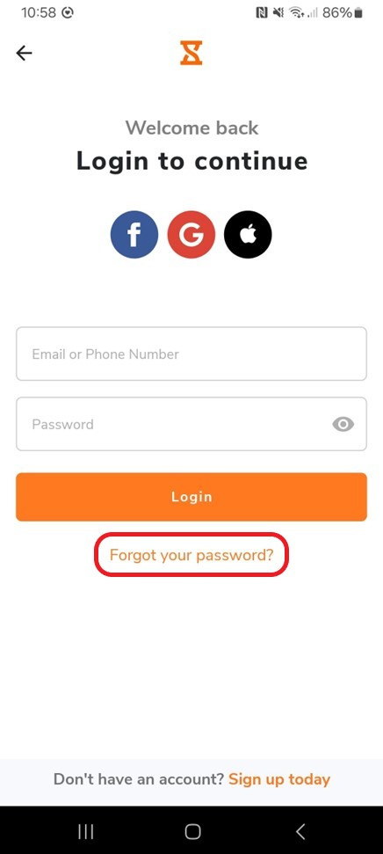
- Select the ‘Forgot your password?’ link.

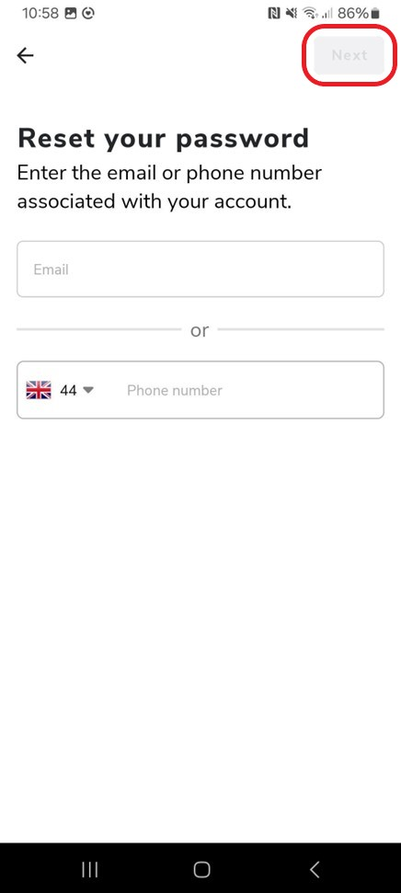
- Enter your MHA email address or the phone number associated with your account and the select ‘Log In’.

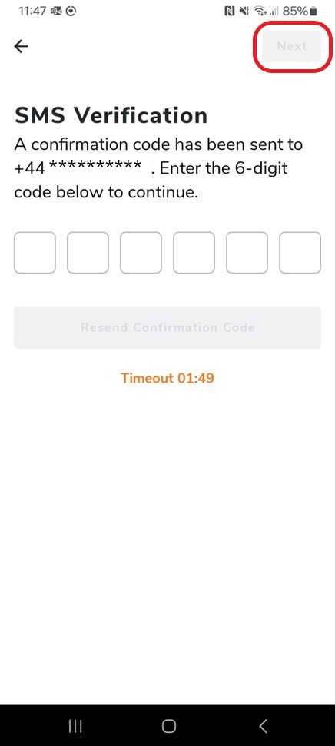
- Enter the verification code that you have received and then select ‘Next’.

- Enter a new password of your choice.

